  - Mode or Modal Value
Key Revision Facts: GCSE Maths

The mode or modal value is simply the number which appears most often. In {6, 3, 9, 6, 6, 5, 9, 3} the Mode is 6, as it occurs most often.
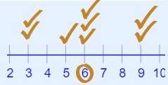

Having two modes is in a list called "bimodal". Having more than two modes is called "multimodal".
Example: {1, 3, 3, 3, 4, 4, 6, 6, 6, 9}
3 appears three times, as does 6.
So there are two modes: at 3 and 6

Download
More Key Fact Revision sheets can be downloaded from
www.andrew-seaford.co.uk/revision

Version information
Date | Arthur | Comment
17-Jan-2021 | Andrew Seaford | Initial release.

